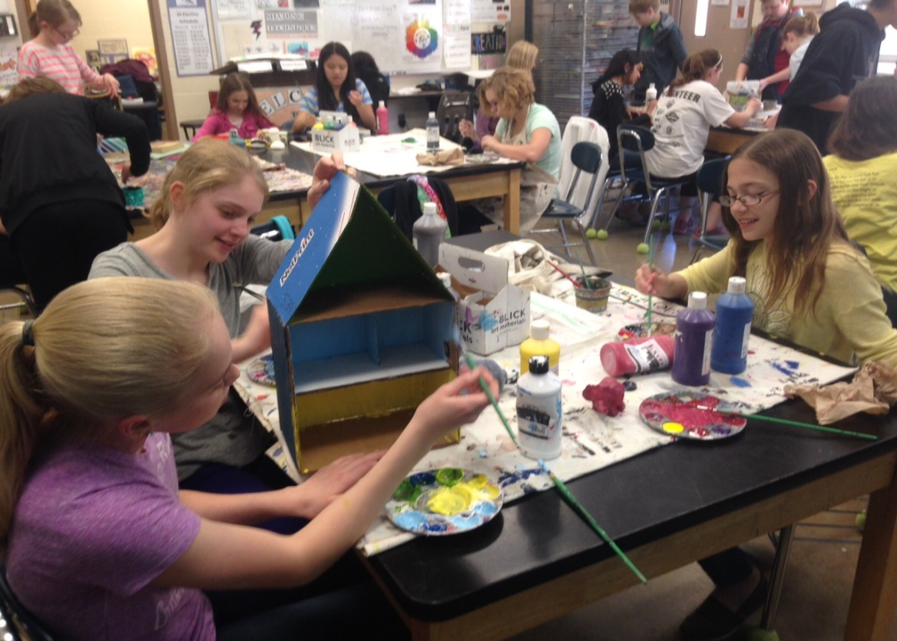 |  | Welcome to Art Club  - with Ms. Flint & Mrs.Kelly!
Mahomet-Seymour Junior High Art |  | ClUB Newsletter
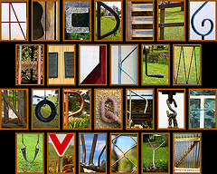
Welcome to Art Club! If 18 weeks of art is not enough for you, then get your fix with Art Club!!!! Together, we will work on several art projects throughout the year, including painting the bricks in the art room! We will also have an opportunity to create work for the district art show, Celebrate Art, which will be held in April at the high school.
Club Guidelines
- What are the requirements to join Art Club? Any 6th, 7th, or 8th grade student that is interested and available on Tuesdays after school is free to join the club. If you decide to join Art Club, there will be a $35.00 school fee to become a member. This fee should be turned into the office by Tuesday, September 24th.
- When will Art Club Meet? Art Club will meet EVERY OTHER Tuesday, from 3:30-4:30 in the Art room 302. Announcements will be made the week of meetings as reminders for members to attend. It is your responsibility to arrange to have a ride home after meetings. Special meetings may also be scheduled if more time is needed to complete time sensitive projects. Students will be given advanced notice of additional meetings.
- What will you do in Art Club? Art Club works on a variety of 2-D & 3-D projects!
Interested in Digital Art???
If Art Club is not enough for you, join Photo/Video Club! This club works on digital art projects using Adobe Photoshop and it meets every other Tuesday in the Art room 302. Our first meeting is Tuesday, September 11th, from 3:30-4pm in the Art room!
What if I Miss Something??? Check out the link for art club on Mrs. Kelly’s website for more information: nkellyart.weebly.com
Still Have Questions??? Email Mrs. Kelly: nkelly@ms.k12.il.us
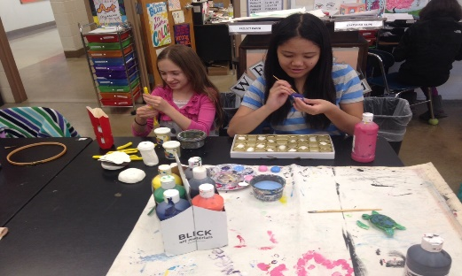

A Look Inside Art Club…

ART CLUB SCHEDULE:
September: 10th, 24th

October: 8th, 22nd

November: 5th, 19th
December: 10th
January: 14th, 28th
February: 11th, 25th

MSJH Art Club Mini Gallery Display

March: 10th , 31st
April: 14th, 28th

Meetings may be cancelled or rescheduled-- ALWAYS listen to the announcements for updates in the schedule!

● There will be an Art Club party on our last meeting, April 28th , in the Art room for all members who have attended throughout the school year.

● All School rules in the Mahomet-Seymour Student Handbook will apply.

